Bryan Miranda ISM 4323 9:30- 10:45AM

**Problem 1) [10 Points] Assume attackers have created a website just like your bank’s/credit union’s   
website. The websites are identical, therefore, there is no way for you to tell the fake website from the   
original one by their appearance. Also assume that checking the address bar (for the correct   
name/address) is not an option since the website’s name is too long and checking the characters one-  
by-one is very tedious. Is there any other way that you check the legitimacy of the websites?   
Please briefly explain how does the measure work.   
Please provide screenshots of how you check the authenticity of a website from your browser.**

The first thing I would check for would be the Lock portion of the website URL . This is probably one of the more obvious ones when it comes to check the authenticity of a certain website on the internet .

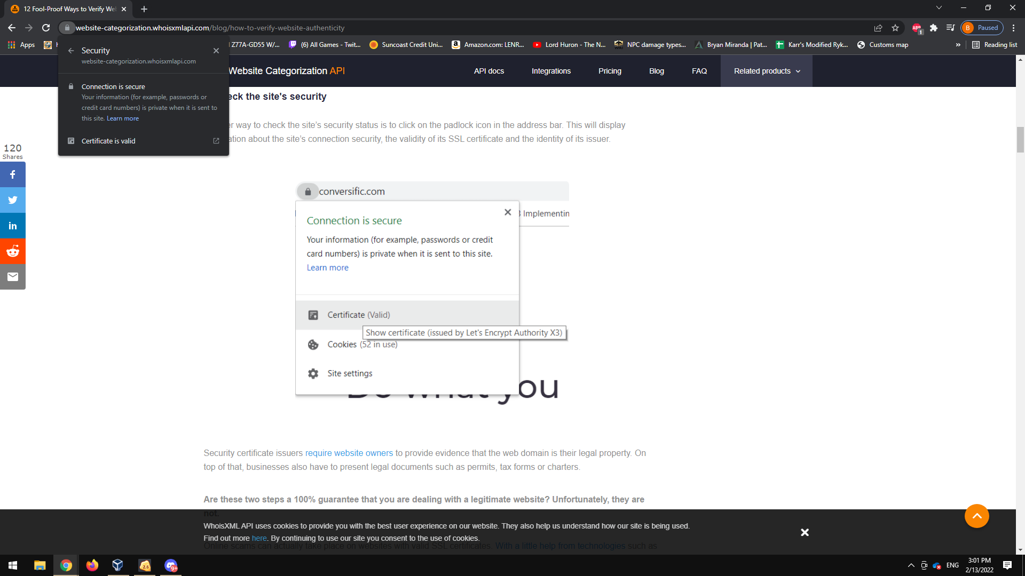

**Problem 2) Using the Terminal on your Centos Operating system complete the following tasks. Please provide screenshots for each step . Please use the Terminal to do every task and not the graphical user interface.**

Steps I took first with errors involved haha.

First I made the directory in the Downloads Folder . mkdir BryanMirandaFolder1 , used the ls command to see if it registered the creation of the folder and then changed directories with cd into the BryanMirandaFolder1 Portion with ( cd / BryanMirandaFolder1 ) moved on to then create the text file BryanMirandaTextFile.Txt within the Folder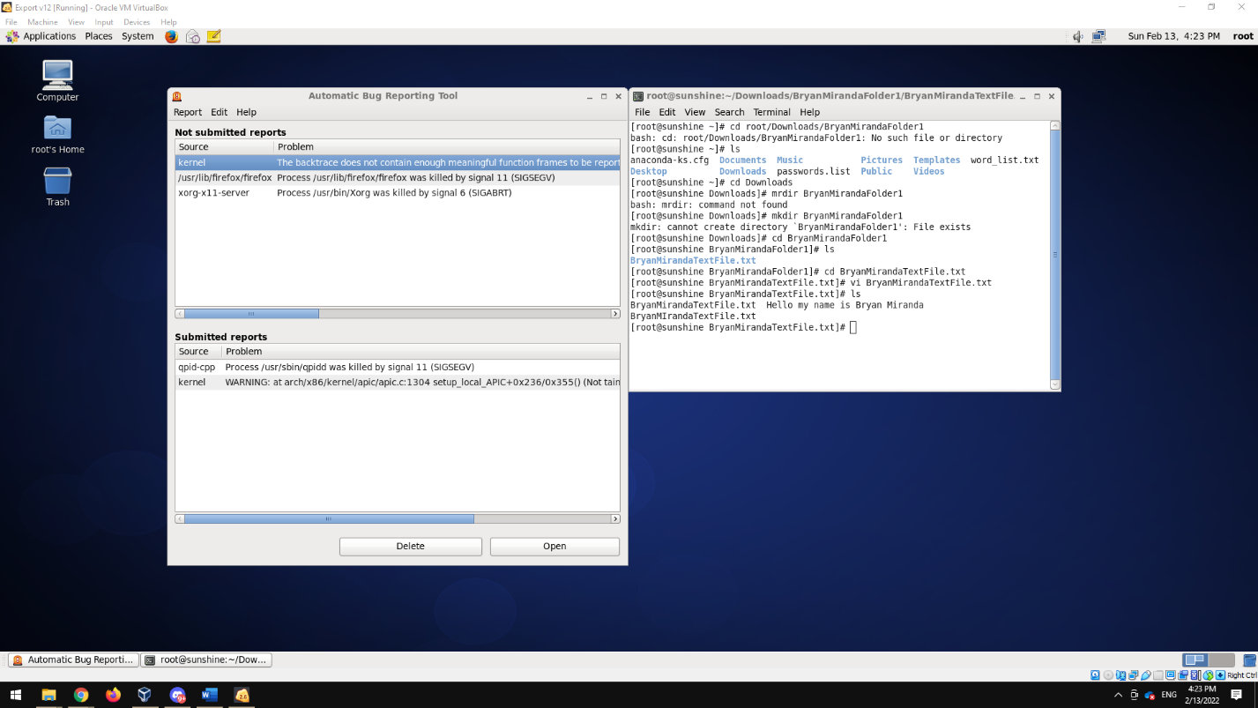

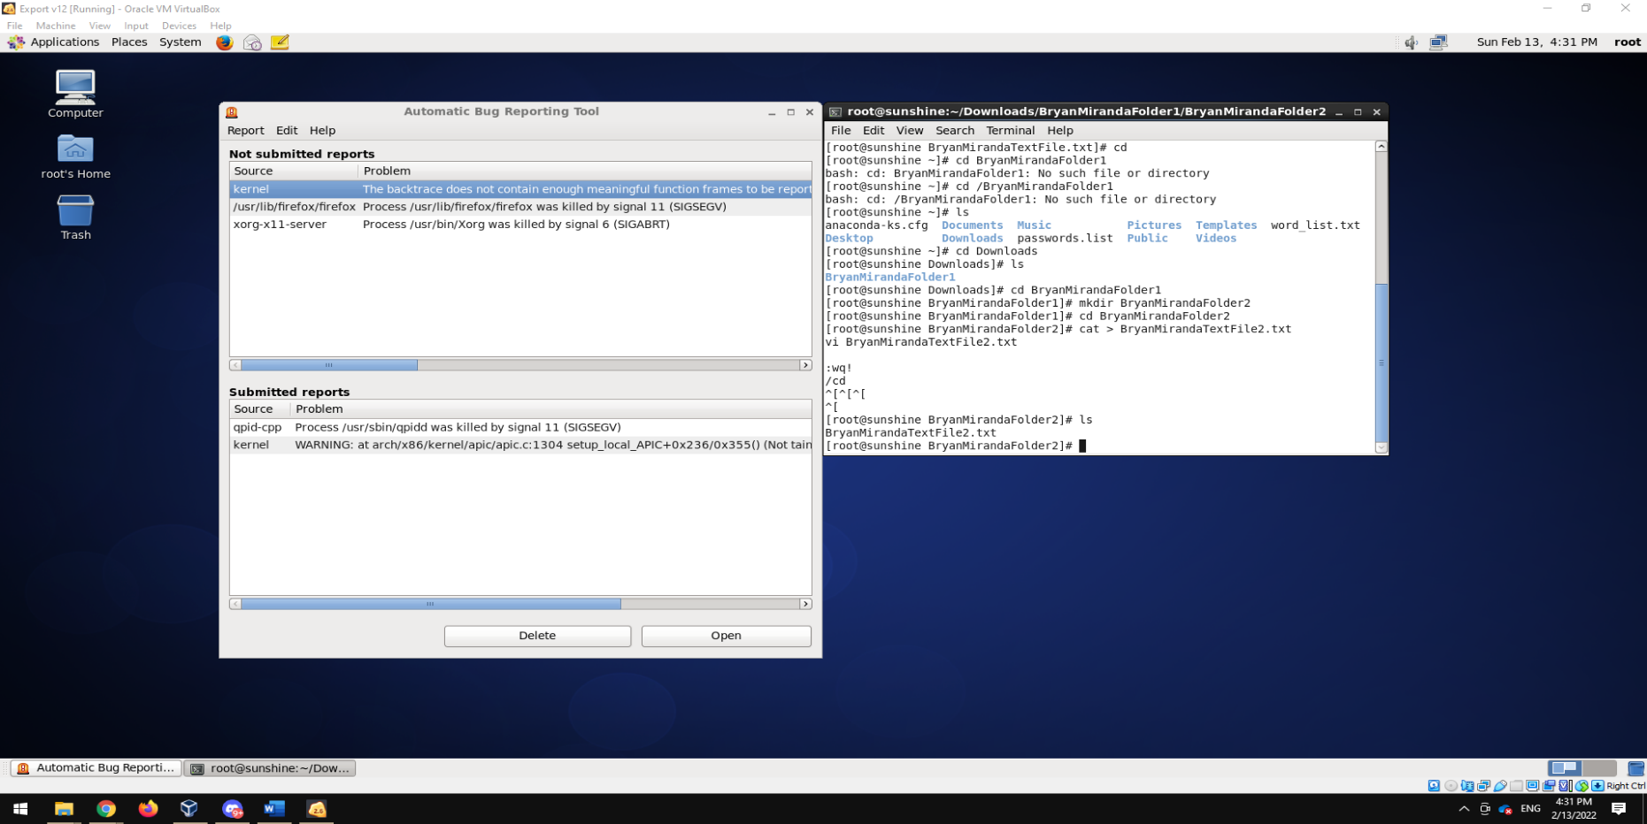**2) Now, while in directory ‘yournameFolder1’, create a folder/directory named   
‘yournameFolder2’ (e.g., rouzbehFolder2).   
• Change directory to the new folder and, using Vim, create a file named   
‘yourfirstnametextfile2.txt’.**

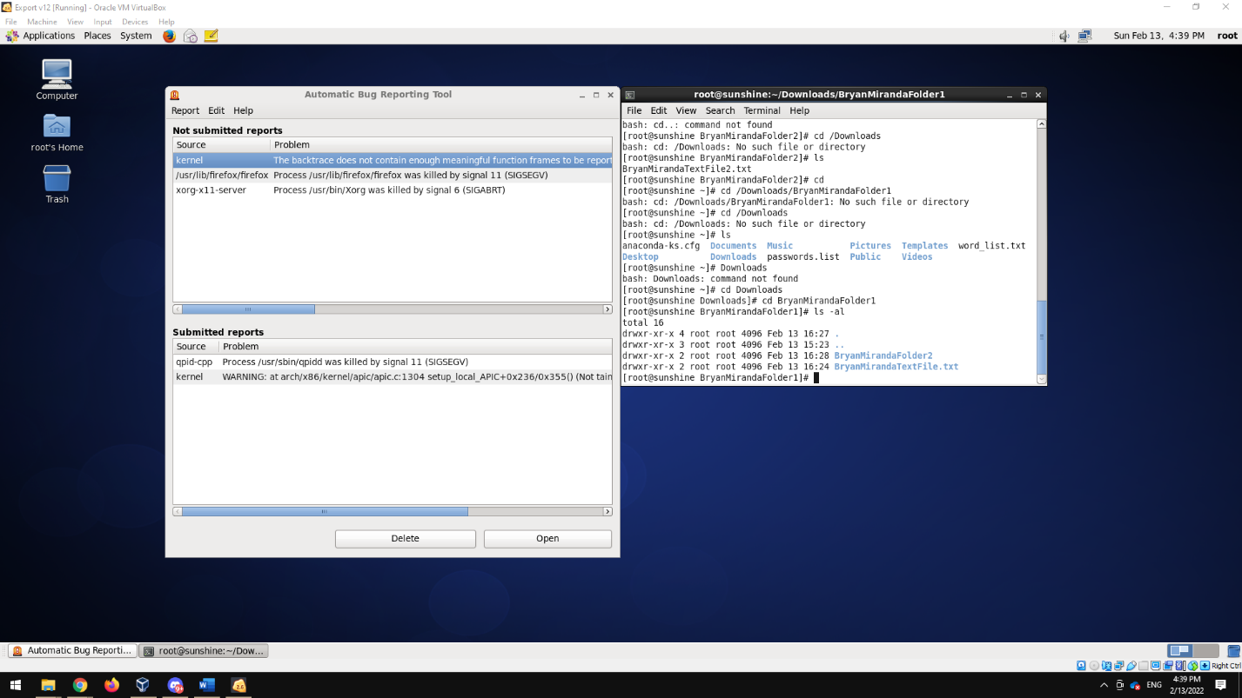**3) Navigate to the first folder you created (‘yournameFolder1’) and use the command to check   
the ownership and permissions of the file you have created (‘yourfirstnametextfile1.txt’).**

**4) Now, change the ownership and group of the file ‘yourfirstnametextfile1.txt’ to ‘alice’. i.e.,   
the owner and group associated with the file will be ‘alice’.   
• Provide screenshots of the commands you’ve used and the outputs.• Again, check the ownership details of the file.**

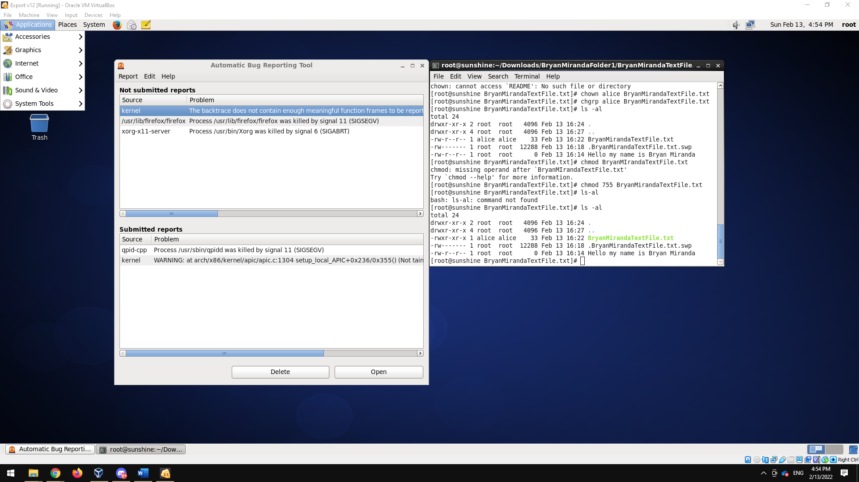**5) Change the permission of the file above (‘yourfirstnametextfile1.txt’): Allow the user ‘alice’   
and the group ‘alice’ to read, write and execute, and everyone else the read and execute   
permissions. Provide a screenshot of each step.**

Both step 5 and 6 are shown in this step.

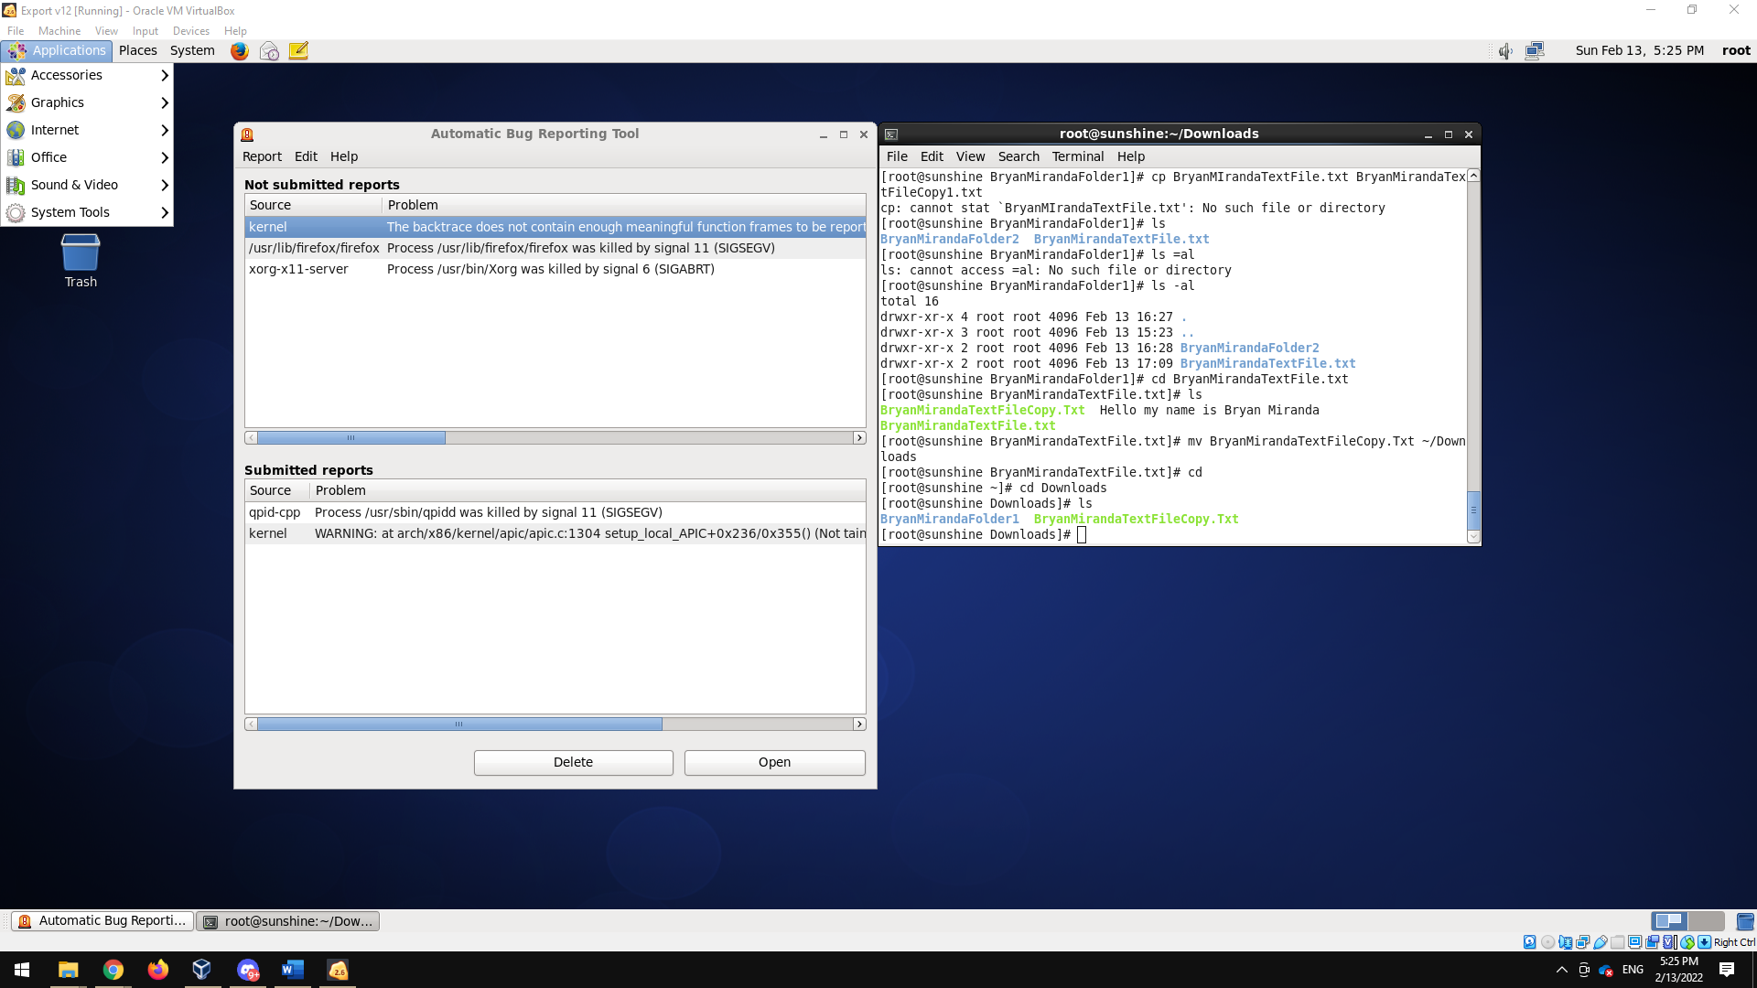**7) Now, using commands, make a copy of the file ‘yourfirstnametextfile1.txt’ in the   
/root/Downloads folder, and name it ‘yourfirstnametextfile1Copy.txt’. Please provide a   
screenshot of the commands and the output.**

**8) Rename the file ‘yourfirstnametextfile1Copy.txt’ to ‘yourfirstnametextfile3.txt’. Please   
provide screenshots**

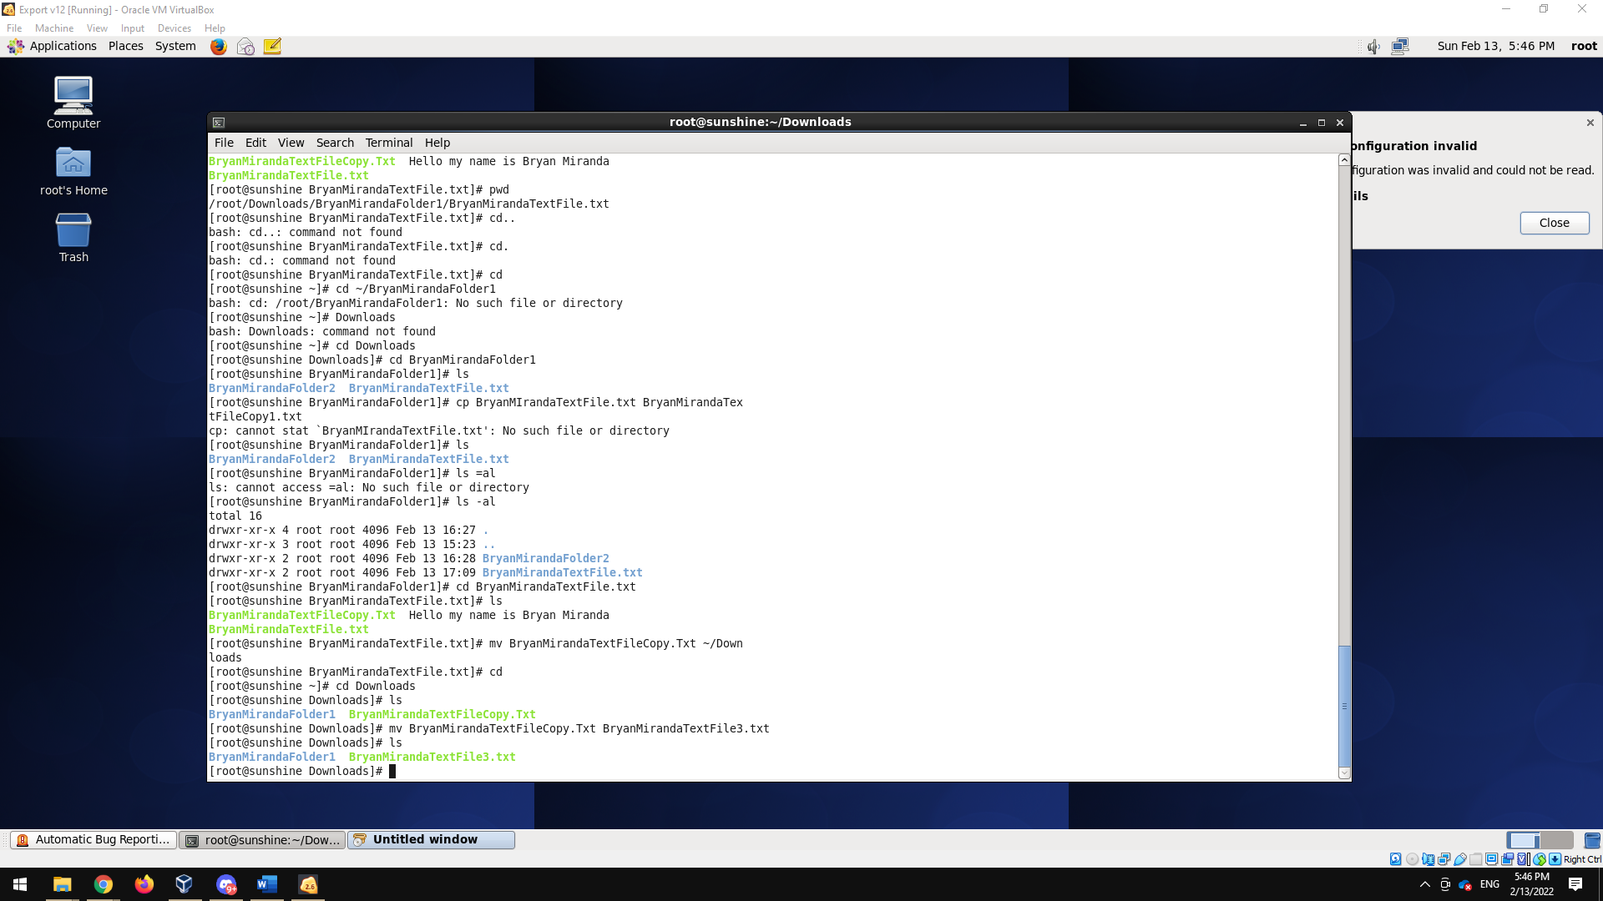

**9)Navigate to /root/Downloads, and from there, delete the folder ‘yournameFolder2’ and all   
of its content using only ONE command.**

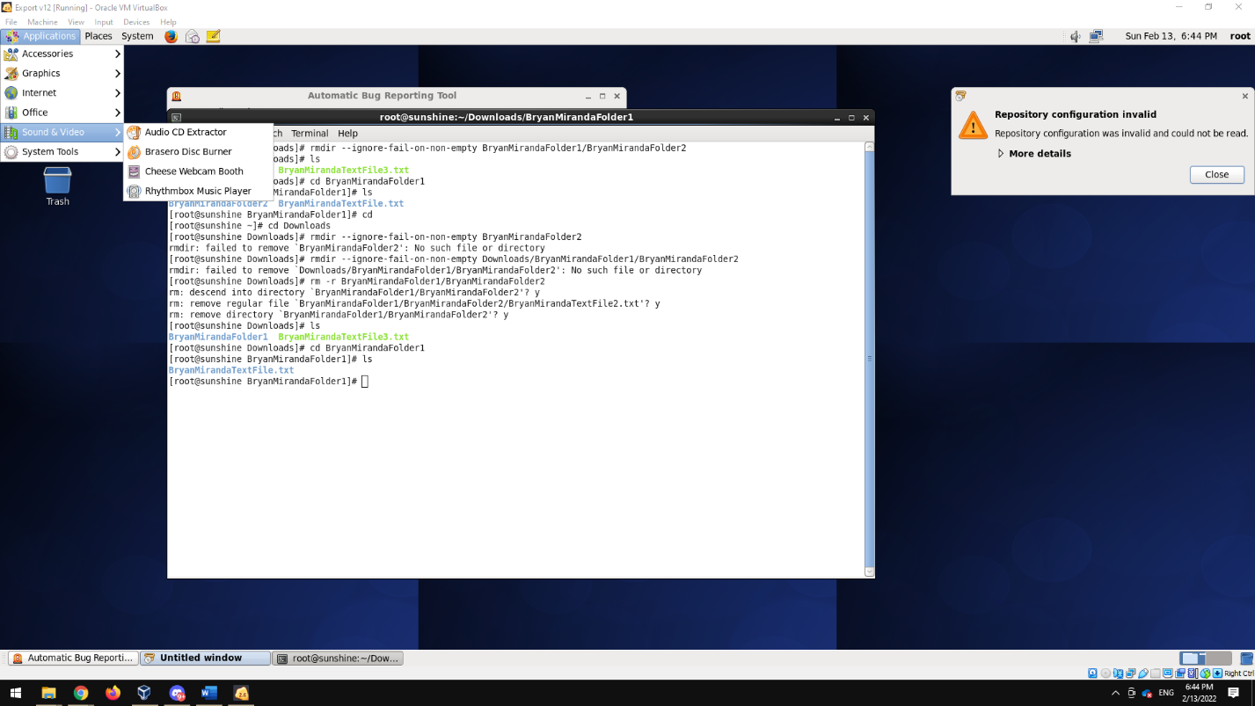

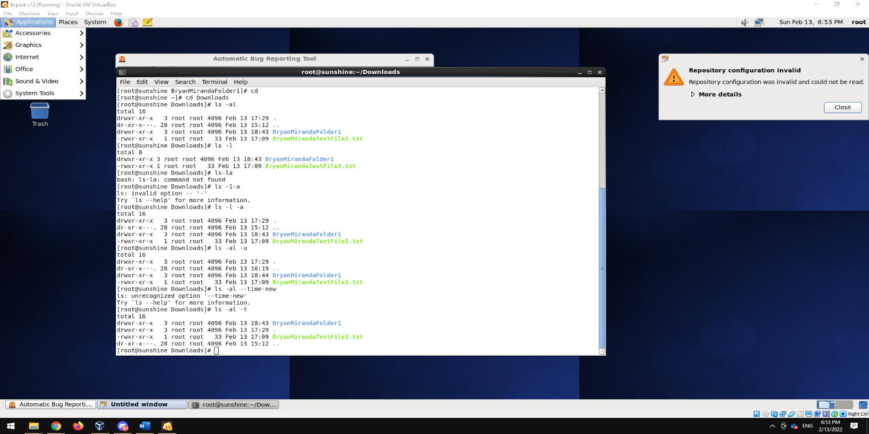**10) Using command ls, what option can we use to view the hidden files as well? How to have ls   
sort the results by time, newest first?**

**Problem 3) [10 Points] Is it possible to list all the files with specific extensions (e.g., .txt) that belong to   
a certain user)? If not, please explain why. If yes, please list all the .txt files on the home directory of   
user ‘root’ that belong to the user root. Please provide screenshots.**

The main command for trying to figure out a specific extension would be to utilize the wildcard function to demonstrate I will be typing in ls *.txt since we are looking for files with that specific extension the asterisk will provide us with all files with that extension.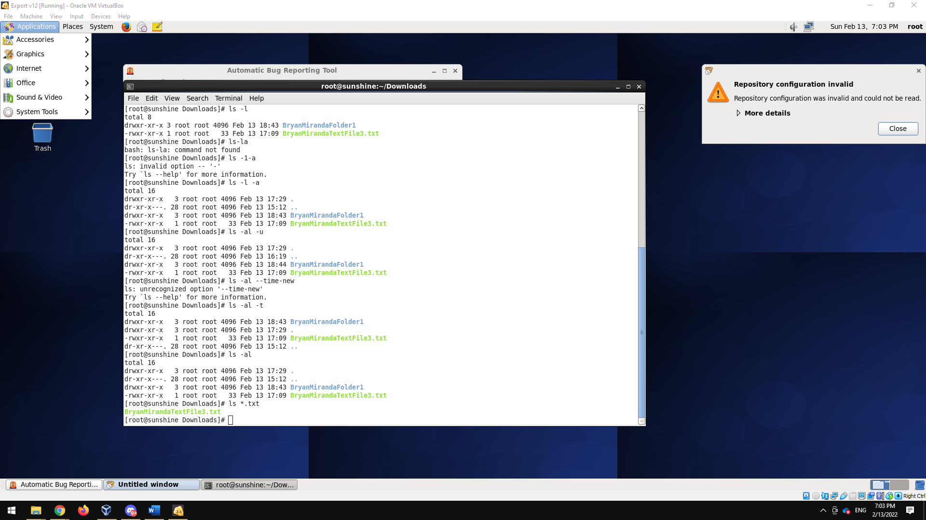

**Using shell expansions (Lecture 3, slide 23):   
1. Write the command to list all the files with two letter extensions.** ls *.??

**2. Write the command to list all the files that start with the letter ‘g’.** ls *.g

**3. Write the command to list all the files that start with letter g and have 3 letter extensions that   
starts with the letter ‘t’.** ls *g??t **4. Write the command to list all the files with 2 letter names (regardless of extension).** ls -al *.??